Honorary Life Membership P r o g r a m

* An Honorary Life Membership (HLM) in Presbyterian Women is conferred upon a woman or man in recognition of faithful service in some area of the church’s work. Moderators, teachers, leaders, officers, pastors, and missionaries have been among the recipients of this honor.
* The funds derived from Honorary Life Memberships are used for Presbyterian Women leadership training costs, support of leadership development events for women, and training leaders for mission interpretation. Honorary Life Membership funds support Presbyterian Women’s Leadership Development grants.
* The church group conferring the honor sends this form along with a check for the appropriate amount to the Treasurer of Presbyterian Women in its presbytery:

Presbytery of the Peaks PW Treasurer 3321 Kingswood Drive, S.W. Roanoke, VA 24018

Make checks payable to **Presbyterian Women**.

* An honorary life pin and personalized certificate will be mailed to the person indicated on the form for later presentation to the honoree. Please mail the form and check at least six weeks prior to the presentation date.

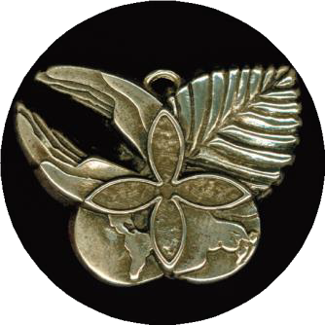

**About the Pin Design**

The caring, supportive hands represent women who seek to build an inclusive community of Presbyterian Women. The leaf represents growth of our personal and corporate response to Jesus Christ as we nurture our faith. The dove indicates our work for peace in our own lives and throughout the world, shown in the globe. At the center of the design is the cross, by which our sins are forgiven and we are freed to live in Christ, who is the center of our lives. The overall design is of a butterfly, the symbol of newness in Christ.

**10K gold HLM pin**

**$250.00**

**Sterling silver HLM pin**

**$95.00**

**Honorary**

**Life**

**Membership**

**Program**

**Honorary**

**Life**

**Membership**

**Program**

**Honorary Life Membership Pin Order Form**

**Please check:** ❑ **Gold Pin ($250.00)** ❑ **Silver Pin ($95.00)**

**IN HONOR OF:**

(Please print or type the name as you want it to appear on the certificate.)

Honoree’s address: City: State: Zip: Phone: E-mail:

(Be assured we will not communicate with the honoree before the presentation date.)

**PRESENTED BY:** Presbytery:

(Name of church group to appear on certificate.)

City/State/Zip: Presentation date:

**SEND PIN AND CERTIFICATE TO:** Name:

Address: City: State: Zip: Daytime phone: