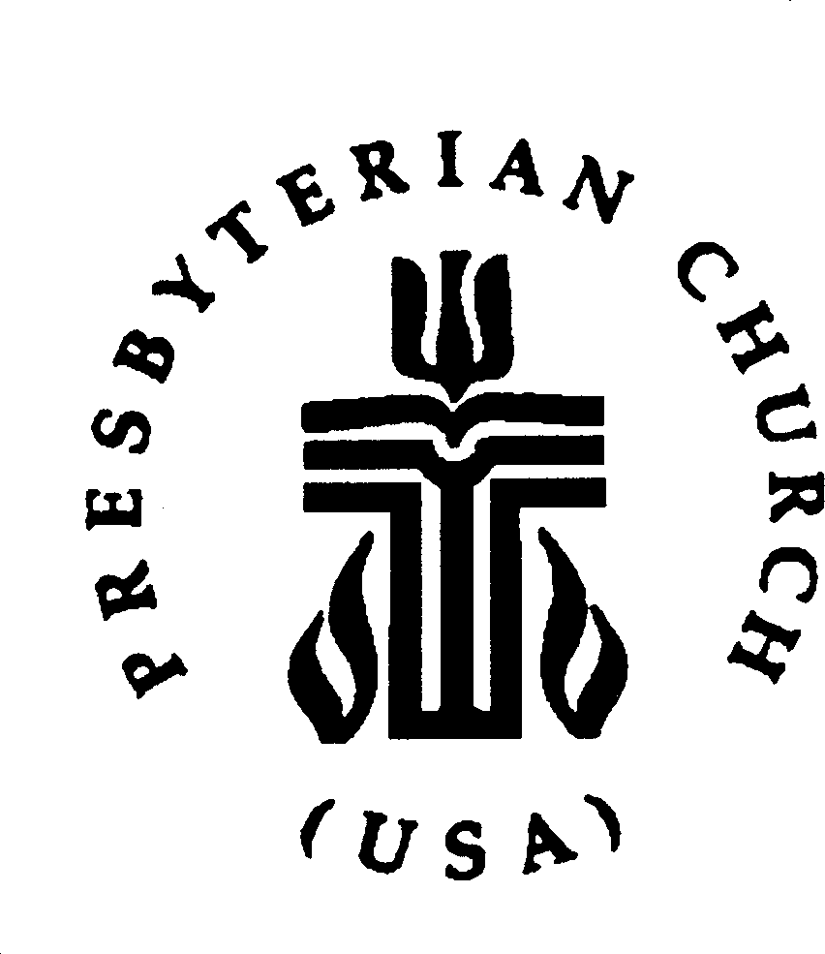
Presbyterian Women Presbytery of the Peaks Synod of the Mid-Atlantic
2020 Financial Support Form

As Presbyterian Women, we make the following Mission Pledge to offer our financial support to PW at the Presbytery, Synod, and Churchwide levels:

number of women @ $3.90 | = | for Presbytery PW Support
number of women @ .50 | = | for Synod PW Support
number of women @ .60 | = | for Churchwide PW Support
We wish to make a further pledge |  | for Presbytery PW Support  for Synod PW Support  for Churchwide PW Support
TOTAL PLEDGE FOR 2020
In addition to our pledge, we also plan to participate in the following areas in 2020:
Birthday Offering
Thank Offering
Fellowship of the Least Coin
Honorary Life Memberships
Memorial and/or Recognition Gifts (funds used for Leadership Development)
Church Women United
Leadership Endowment Fund
Various Denominational Programs (Peacemaking Offering, Hunger Fund, etc.)
Name of Church: Today’s Date: PW Moderator/Contact Person: Street Address: City, State, Zip: Telephone: ( )
PLEASE complete and return this Financial Support Form by November 20, 2019, to: The Peaks PW Moderator, P. O. Box 744, Blue Ridge, VA 24064.
Questions: Contact Helen Dean, The Peaks PW Moderator, at 540-362-5169 or hbarb55@cox.net.

Do not send money with this form – Pay in 2020!
(Congregations may make financial support payments in four quarterly installments during the year.)

